Communication between Client and Server

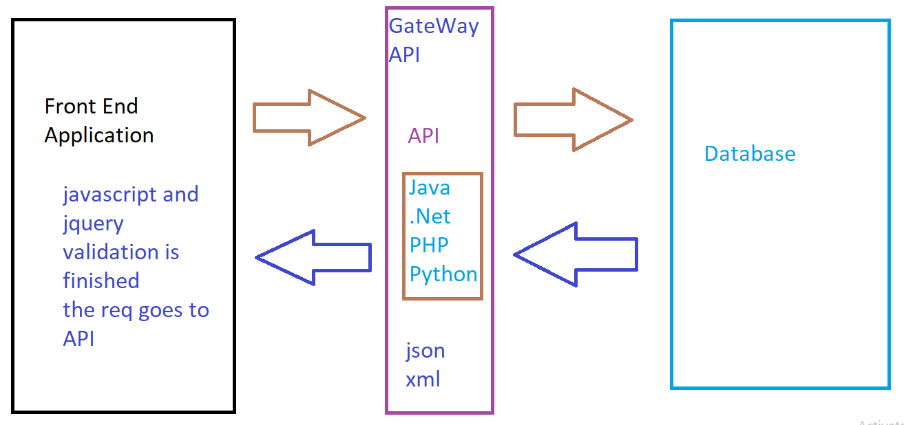

jQuery Sliders

1. Bxslider
2. wowslider

## bxSlider

Process of downloading and using the web page. First go the website “<https://bxslider.com/install/>”

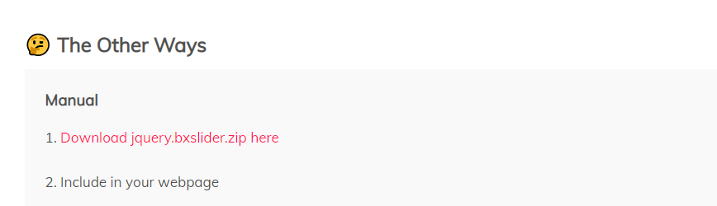

It will download the file name as jquery.bxslider.zip and extract the zip file and paste the folder into current working directory

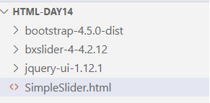

Example 1:

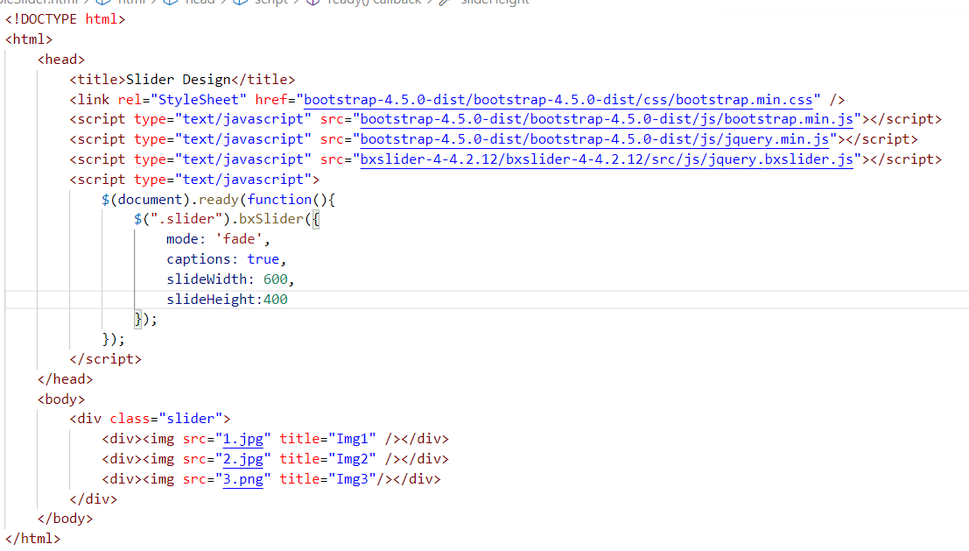

Child and Parent

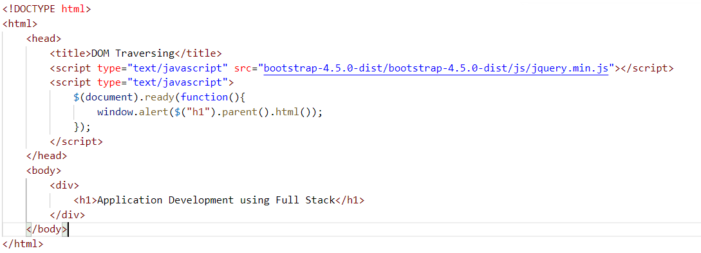

Task

